# Supply chain simulation: the guide and assignment

## Objective and prerequisites

By completing the business simulation you will learn basic concepts for inventory management in a supply chain. You will explore the relationship between inventory control policies, the supply chain structure, and the economic and operational KPIs of the supply chain.

## Glossary

**Supply chain (supply network) –** a network of processes and flows between supply chain partners that are orchestrated to provide customer service and fulfill customer's demands.

**Economic order quantity** – a mathematical model derives an optimal order quantity that would minimize the total inventory holding and replenishment cost

**Fixed order size policy (Q, R)** – an inventory control policy that uses a fixed order size and a reorder point. Re-order is triggered whenever the stock level falls below the reorder point.

**Fixed period policy (T, S)** – an inventory policy that uses a fixed re-order periodicity. Order size is calculated by subtracting the available inventory from the pre-defined maximum inventory level.

**Service level –** a metric that describes the quality of customer service.

**Safety stock** – an additional stock aimed at preventing out-of-stocks due to demand, lead time, or product quality variability in a supply chain. The safety stock is calculated based on the various uncertainty factors in a supply chain.

**Cycle stock** – the stock formed by the regular shipments, which covers the planned product requirements.

**Supply chain resilience** – the ability of a supply chain to adapt to changes in the environment, and to maintain the performance metrics in an acceptable range.

## Problem formulation

Company "K" is a distributor of consumer goods. The company's supply chain includes the following echelons:

* suppliers (the main supplier is located in China, the alternate supplier --- in Finland);
* distribution center (located in Central Federal District);
* 3 regional warehouses (located in the North-Western, Krasnodar, and Volga regions);
* customers (retailers and wholesalers) located in the Central Federal District, Northwestern Federal District, Krasnodar Krai, and Volga Region).

The supply chain diagram is shown in Figure 1. Customers are aggregated by region to simplify the analysis. Demand in each region, except the Central, is assigned to the regional warehouse. Demand in the Central Federal District is assigned to the central distribution center. All regional warehouses are supplied from the central distribution center. The distribution center sources its products directly from the supplier.



Figure 1. The company's supply chain diagram with main parameters (green) and decisions (blue)

The input data for the model are:

* customer demand and sale price for each region;
* transportation time and cost for each route;
* order processing time for each warehouse and supplier;
* purchase prices for different suppliers;
* initial stock levels for all warehouses.

The statistical analysis of historical demand is provided in Table 1. Daily demand follows the normal distribution.

*Table 1. Historical demand statistics*

|  |  |  |  |
| --- | --- | --- | --- |
| **Region** | Average daily demand, ton | Std. deviation of daily demand, ton | Sale price, RUB/ton |
| NW | 10 | 2 | 20000 |
| Central | 20 | 5 | 20000 |
| South | 5 | 1 | 20000 |
| Volga & Ural | 15 | 3 | 20000 |

Table 2 provides data for supply lead times and current inventory control policies.

*Table 2. Supply lead times, costs, and current inventory control parameters*

|  |  |  |  |  |  |  |  |  |
| --- | --- | --- | --- | --- | --- | --- | --- | --- |
| **Supply chain node** | **Inven-tory Con-trol Policy** | **Order processing time, days** | **Lead time, days** | **Inventory holding + 3PL warehouse storage rates RUB / (ton * day)** | **Supply cost (RUB/shipment)** | **R, ton** | **Q, ton** | **Initial stock** |
| China supplier | - | 7 | Triangular (15;30;20) | - | 1 500 000 | - | - |  |
| EU Supplier | - | 1 | Triangular (5;10;7) | - | 500 000 | - | - |  |
| Central DC | R,Q | 1 | см. поставщиков | 50 + 20 | см. поставщиков | 800 | 3000 | 2000 |
| Warehouse NW | R,Q | 1 | 2 | 30 + 15 | 75 000 | 150 | 300 | 200 |
| Warehouse S | R,Q | 1 | 5 | 30 + 15 | 150 000 | 100 | 100 | 150 |
| Warehouse Volga + Ural | R,Q | 1 | 2 | 30 + 15 | 110 000 | 100 | 150 | 150 |

Purchasing prices: China supplier – 5000 RUB/ton, EU Supplier – 6000 RUB/ton

You are required to analyze and optimize inventory control policies, and to decide whether it is appropriate to switch to an alternative supplier. The effectiveness of the decisions is measured by net profit, which is calculated from the revenue, costs of purchasing, and logistics costs. In addition, the proposed solution must maintain the required service level. To measure service level, the demand fill rate is used, which is the ratio of delivered product volume to customer demand. To reach the goal, you will accomplish 5 tasks. Next, we provide a brief description of these tasks, and instructions for downloading and operating the software.

### Task 1. Analysis of the baseline scenario

Import the provided scenario data (SCM Baseline ALX214.xlsx) into the Anylogistix software. Run the simulation experiment and analyze the provided dashboards.

You can view the aggregated values for the supply chain as well as detailed data for each supply chain node (Figure 2). You can filter the table or export it to Excel if needed.

The output economic metrics include:

* Facility Costs for warehouses are based on the peak storage requirements and unit facility cost;
* Inventory Carrying Costs are calculated from the inventory level and unit carrying cost;
* Inventory Spend – the amount paid to the supplier;
* Transportation Cost;
* Total Cost – the sum of above costs;
* Revenue from product sales;
* Profit is based on Revenue and Total Cost.

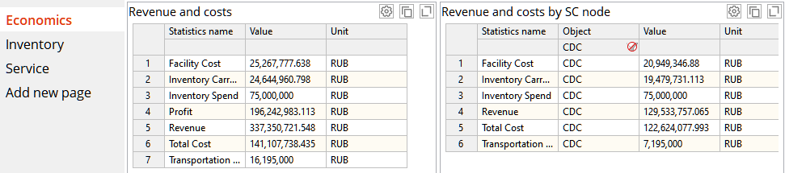

Figure 2. Economic indicators dashboard

Describe the results of your analysis of the performance metrics and your conclusions in the report.

*Operational supply chain metrics are shown in Figures 3 and 4.*

* Inventory dynamics for all warehouses;
* Orders and Shipments for Central DC;
* Detailed inventory carrying cost for each warehouse;
* Service level dynamics (Per customer)
* Customer demand (per customer and aggregated)
* Lost sales due to out-of-stock per customer

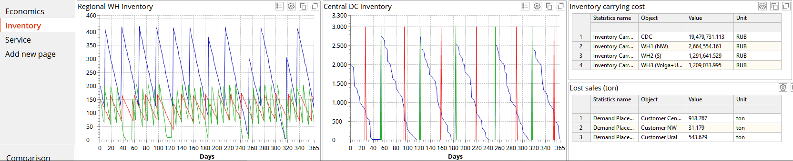

Figure. . Inventory indicators dashboard

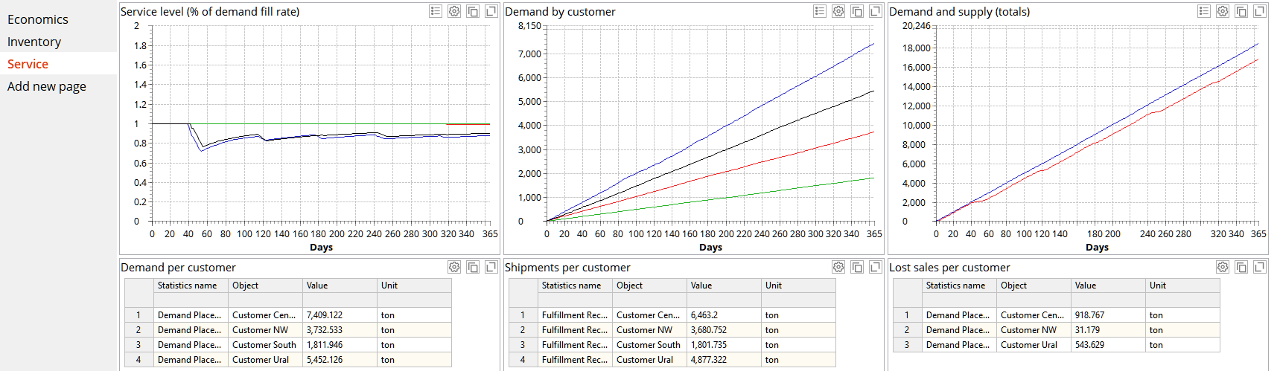

Figure 4. Service level dashboard

### Task 2. Improvement of inventory control policies

Create a copy of the baseline scenario and use calculations and simulation experiments to improve the supply chain performance. The supply chain uses the fixed order size inventory control policy (Q, R). The optimal order size should provide the least possible total inventory holding and replenishment cost. There are some models aimed at establishing the optimal order size, such as the Economic Order Quantity model. Please note, that such models should be adapted to the particular case. You can try using it as a starting point and then improve your results via experimentation.

The basic Economic Order Quantity can be calculated with the formula:

*where – demand per period, -inventory holding cost for the same period, -cost for each re-supply order.*

Reorder point is a threshold level for placing the next order. This quantity should be enough to fulfill customer demand until the next shipment will arrive. To calculate it, consider supplier lead time, customer demand, and demand variability. There are some models to compute the reorder point, but you may need to experiment with it as well.

After you’ve finished adjusting the inventory control policy, compare the results of your improved scenario to the baseline scenario. Describe the changes in the policy and performance metrics in the report.

### Task 3. Consider switching to another supplier

Long lead time and high lead time variability for the Chinese supplier requires a large safety stock to counter-balance the uncertainty. In this task, you are required to analyze an alternative supply chain structure that uses an EU supplier that provides a shorter lead time but at a higher cost.

### Task 4. Perform supply chain risk analysis

There are multiple risk factors in a supply chain, such as supplier failures, 3pl rates variability, demand spikes. Anylogistix can assess the influence of such factors on the supply chain performance with the Risk Analysis Experiment. In this task, you will compare how the two supply chain structures (with a Chinese and EU supplier) can handle a short-term spike in demand. The instruction is provided in the next section.

### Task 5. Assessment of the integral effect of proposed changes with the DuPont model

In this task, you will compare the integral effect of proposed changes using the Strategic Profit Model (DuPont Model). We have provided a template Excel workbook (DuPont – Baseline.xlsx) that you must fill with data from your scenarios. You will find the necessary data in the Economics dashboard (Revenue and cost), Inventory Dashboard (average inventory level), and purchasing price (Sale Batch table).

## Anylogistix Software

To complete the supply chain analysis you will need to install Anylogistix software. You can download the free **Personal Learning Edition** of Anylogistix here: <https://www.anylogistix.com/downloads/>

Fill a short registration form on the website to download the software.

**Anylogistix System Requirements:**

* CPU: Intel Core i5
* RAM: 8 Gb
* Disk space: 1 Gb
* OS Microsoft Windows x64 (Windows 10 or Windows Server).

If you are on an Intel Mac, you can install the software inside the virtual machine. You can use the VM with LogicNet we’ve provided. See installation instructions in class files in Teams.

Newer M1 Macs currently can’t run Windows VMs.

## Instructions for operating the software

Source data for the baseline scenario are provided in the “**SCM Baseline ALX214.xlsx**” file. To import the scenario use the **File/Import Scenario** menu. This should open the import window shown in Figure 5. Press the ellipsis (…) button to select the “**SCM Baseline ALX214.xlsx**” file.

Figure. 5. Import scenario settings

After the import is complete, Anylogistix will add the scenario to the Simulation (SIM) page. An overview of the user interface is provided in Figure 6. To adjust input data, open the Data section. It’s convenient to filter the tables that are used in the active scenario (In use tab).

Figure 6. How to find input data for the scenario in Anylogistix

You can edit the cell values directly. Some cells contain complex data consisting of multiple elements. To edit such values, double-click a cell. A dialog window will appear (Figure 7).

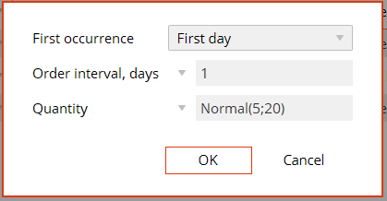

Figure. 7. Editing multiple parameters in a cell

You can adjust multiple cells at once. Select multiple cells using mouse drag, or Shift/Ctrl keys. To adjust all selected cells, press Space. A dialog window for value input will appear (Figure 8).

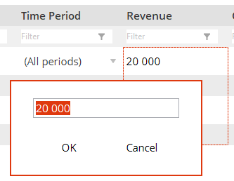

Figure 8. Editing multiple cells at once

By default, Anylogistix uses American local to display dates. You can switch it to a more familiar format using the **Settings/Properties** menu (Figure 9).

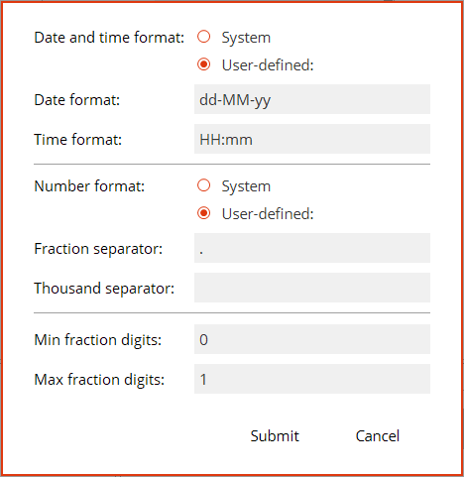

Figure 9. Setting numeric and date/time formats

The model is implemented in Anylogistix as a Simulation scenario. The main supply chain entities are Customers, Distribution Centers, Factories, and Suppliers. These are implemented as separate types of agents. Each agent type follows a defined protocol of communication with other agents. For example, Customers can generate demand and place orders, as well as receive shipments. Distribution Centers can collect customer orders and send shipments. They can also order and receive products from the upstream echelons to maintain inventory.

Exact rules of interaction within the supply chain are specified using policies. For example, a **Sourcing policy** controls the choice of the supplier, **Shipment policy** controls how the outgoing shipments are formed.

The scenario is configured by filling in data tables that define the structure, parameters, and interaction rules of supply chain entities. The main entities of the supply chain model in Anylogistix are shown in Figure 10.



Figure 10. The main supply chain entities in the Anylogistix model.   
The corresponding table names are displayed in bold

Material and financial flows in the supply chain model are initiated by customer demand, the parameters of which are specified in the Demand table (Figure 11.). The model uses a periodic demand type that is described by two parameters --- the periodicity (in days) and the quantity. Both parameters can follow a probability distribution, but to simplify calculations we use fixed periodicity and normal distribution for demand.

Figure 11. The Demand table

Customers select the source of supply according to the configured sourcing policies (Sourcing table, Figure 12). In this model, customers receive goods from warehouses. Regional warehouses, grouped into a set [Regional WH] source products from Central DC. The central DC in the baseline scenario sources its product from China Supplier.

The warehouses, in turn, ship goods according to the configured shipment generation policies (Shipping table).

Figure 12. The Sourcing table

To maintain the inventory, DCs use inventory policies (Inventory table) that control the frequency and size of orders. The inventory policy is the most important parameter of the warehouse that must be adjusted during your analysis (Figure 13).

Figure 13. The inventory table defines a set of rules controlling order frequency and size

The baseline scenario uses a fixed order size policy (RQ Policy), the parameters of which are order size Q and reorder point R. The order size is determined by the ratio of ordering and storage costs. The reorder point is determined by lead time, demand variation, and supplier reliability. By changing these parameters, you can influence the ordering and storage cost. The facility cost is influenced by the peak inventory volume, thus it is also dependent on the inventory policy parameters. Other inventory policies such as Min/Max or Fixed Periodicity can be selected.

Replenishment orders are passed to the supplier, who then generates shipments following the Shipping policy set for it. Unlike warehouses, a supplier's capacity and available product quantity are not limited.

The nodes in the supply chain are linked by routes (Paths table), which determine the type and capacity of the vehicles used for delivery (Vehicle Types), as well as the distance and lead time.

According to the configured supply chain structure and policies, the Anylogistix software can simulate the behavior of the supply chain for a given time horizon (1 year in our case). While simulation is running, the software collects statistics on the performance of all the supply chain elements, such as inventory levels, orders, lost sales, shipments, cost, capacity utilization, etc. This data can be visualized using dashboards in Anylogistix or can be exported to external tools. You can also export each dashboard to Excel.

The simulation model can’t provide an optimal solution, it will just tell you how the supply chain will perform according to the rules configured in the scenario. You will need to experiment with the model by adjusting the parameters and comparing the results.

In addition to the simple Simulation Experiment, there are also special experiment types:

* The comparison experiment will run the simulation several times and average the results.
* Risk analysis experiment helps to assess the supply chain resilience to risk factors.

### Task 1. Analysis of the baseline scenario

In this task, you will need to run the simulation experiment for the baseline scenario and to analyze the dashboards (Figure 14). Write your conclusions about the supply chain issues and possible causes.

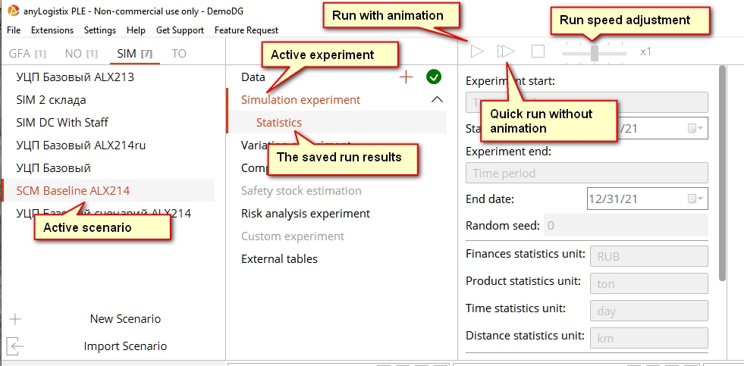

Figure 14. Running a simulation experiment in Anylogistix

The output economic metrics (Figure 2) include:

* Facility Costs for warehouses are based on the peak storage requirements and unit facility cost;
* Inventory Carrying Costs are calculated from the inventory level and unit carrying cost;
* Inventory Spend – the amount paid to the supplier;
* Transportation Cost;
* Total Cost – the sum of above costs;
* Revenue from product sales;
* Profit is based on Revenue and Total Cost.

You can view the aggregated values for the supply chain as well as detailed data for each supply chain node. You can filter the table or export it to Excel if needed.

*Operational supply chain metrics are shown in Figures 3 and 4.*

* Inventory dynamics for all warehouses;
* Orders and Shipments for Central DC;
* Detailed inventory carrying cost for each warehouse;
* Service level dynamics (Per customer)
* Customer demand (per customer and aggregated)
* Lost sales due to out-of-stock per customer

You can enlarge each plot and explore it interactively if needed (Figure 15).

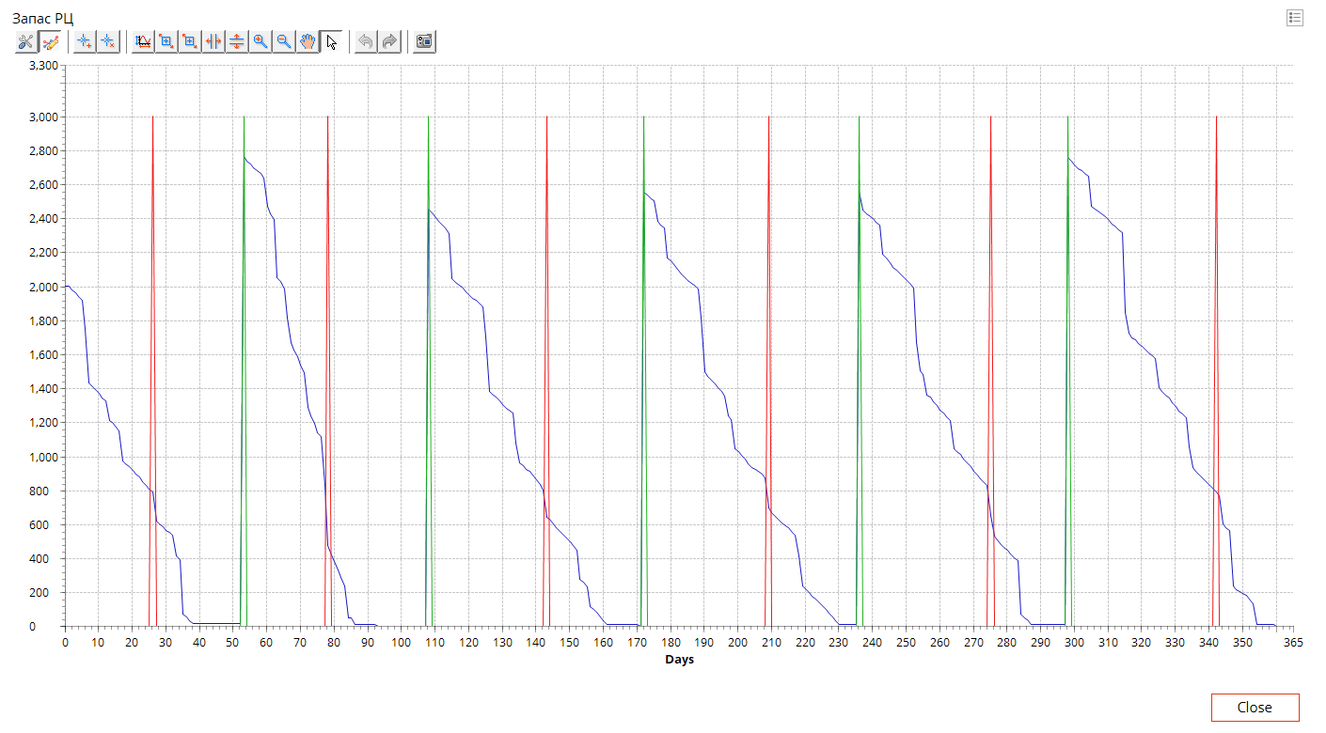

Figure 15. Exploring the inventory level at Central DC

After the simulation is complete, you can press the Stop button on the experiment control panel (Figure 16) to save the results. You are advised to change the default “Statistics” title for the results to something more meaningful. This will help you to distinguish the results from multiple scenarios later on.

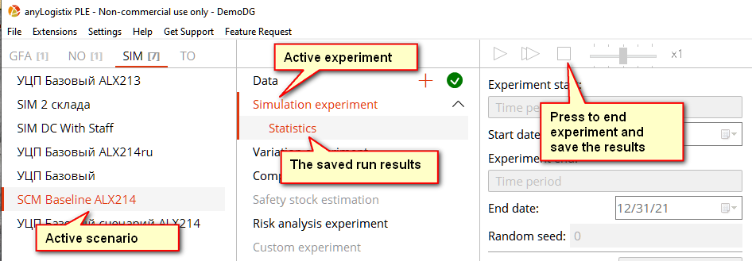

Figure 16. Saving the experiment results

### Task 2. Improvement of inventory control policies

Create a copy of the baseline scenario and use calculations and simulation experiments to improve the supply chain performance by right-clicking the baseline scenario and selecting “Creating Copy as SIM” (Figure 17).

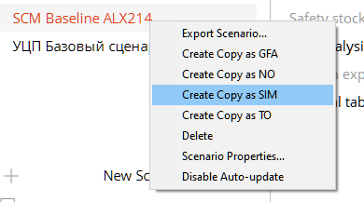

*Figure 17. Duplicating a scenario*

The supply chain uses the fixed order size inventory control policy (Q, R). The optimal order size should provide the least possible total inventory holding and replenishment cost. There are some models aimed at establishing the optimal order size, such as the Economic Order Quantity model. Please note, that such models should be adapted to the particular case. You can try using it as a starting point and then improve your results via experimentation.

The basic Economic Order Quantity can be calculated with the formula:

*where – demand per period, -inventory holding cost for the same period, -cost for each re-supply order.*

Reorder point is a threshold level for placing the next order. This quantity should be enough to fulfill customer demand until the next shipment will arrive. To calculate it, consider supplier lead time, customer demand, and demand variability. There are some models to compute the reorder point, but you may need to experiment with it as well.

After you’ve finished adjusting the inventory control policy, compare the results of your improved scenario to the baseline scenario. Describe the changes in the policy and performance metrics in the report.

The supply chain model uses random numbers to simulate the uncertainty factors such as demand or lead times. As a result, all output metrics are also random numbers. To get meaningful results, multiple runs (replications) of an experiment are needed. Anylogistix includes a Comparison experiment to perform this task. It will run the simulation a specified number of times and average the results. The free PLE version has a limit of 10 replications.

Whenever you need to compare the metrics for different scenarios, use the Comparison experiment. Set the number of replications to 10 and select scenarios to compare (Figure 18).

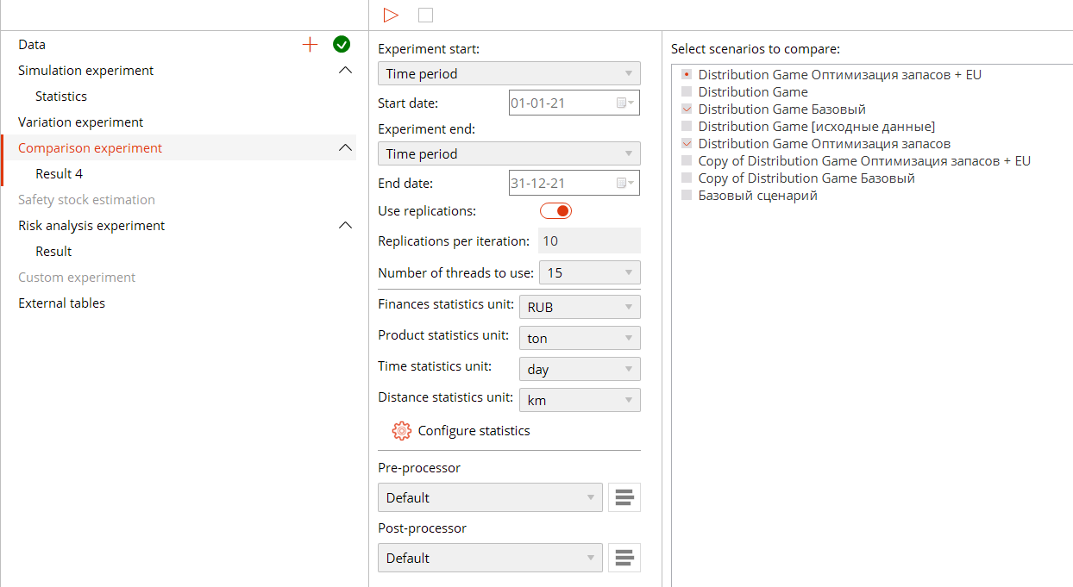

Figure 18. Comparison experiment in Anylogistix

The aggregated results for multiple runs of each scenario will be displayed (Figure 19).

Figure 19. Comparing the averaged results from multiple replications of each scenario

### Task 3. Consider switching to another supplier

Long lead time and high lead time variability for the Chinese supplier requires a large safety stock to counter-balance the uncertainty. In this task, you are required to analyze an alternative supply chain structure that uses an EU supplier that provides a shorter lead time but at a higher cost. Create a copy of the scenario from the 2nd task. In this copy, switch the Sourcing policy for the Central DC from Chinese to the European supplier (Figure 20). You will also need to adjust the inventory control policies as well.

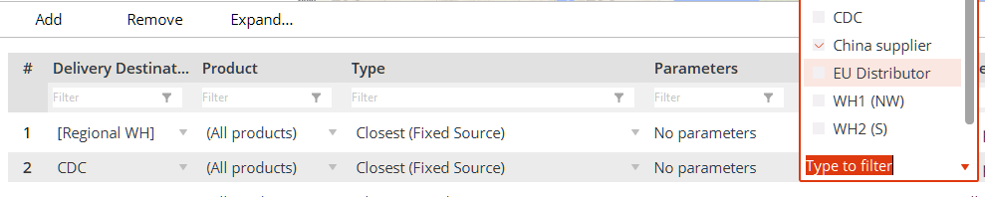

Figure 20. Selecting European supplier in the Sourcing table

### Task 4. Perform supply chain risk analysis

There are multiple risk factors in a supply chain, such as supplier failures, 3pl rates variability, demand spikes. Anylogistix can assess the influence of such factors on the supply chain performance with the Risk Analysis Experiment. In this task, you will compare how the two supply chain structures (with a Chinese and an EU supplier) can handle a short-term spike in demand.

Anylogistix allows describing the risk factors using the Events table (Figure 21). This table lists possible events with an associated probability. Some events may trigger other events as well. In our data, there are two such events – a demand spike starting in March with a given probability, and the return of demand to normal levels which is triggered by the beginning of the spike and delayed by 30 days from that point.

Figure 21. Adjusting the Events table – set the probability of Demand spike to 1

For analysis required in this task, you’ll need to copy the scanarios from Tasks 2 and 3 and adjust the probability of the demand spike to 1.

After you’ve adjusted the demand spike probability, you will run the Risk analysis experiment. The configuration of this experiment includes the choice of a service level metric for comparing scenarios and the two service level values needed to assess the time to recover back to normal. The **Target Service Level** parameter defines the service level metric used to analyze scenarios. In our case, this should be set to **Service Level by Products**. This metric is calculated by dividing the supplied quantity by the demand. The **Failure service level** is the lowest acceptable service level that will mark the beginning of the problematic period after the realization of risks. The **recovery service level** will mark the end of the recovery period (Figure 22).

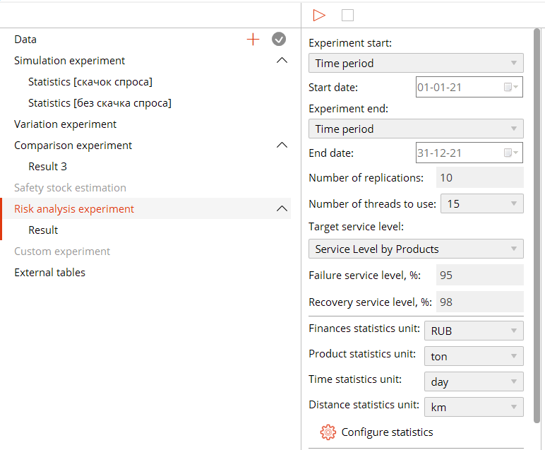

Figure 22. Configuring the risk analysis experiment

After running 10 replications, the Risk analysis experiment will automatically create the dashboards for scenario comparison. The most useful data is available on the Target Service Level dashboard. It will show the recovery dynamics for the target service level (Figure 23). The Events and Recovery page (Figure 24) will display the histogram of the time to recover.

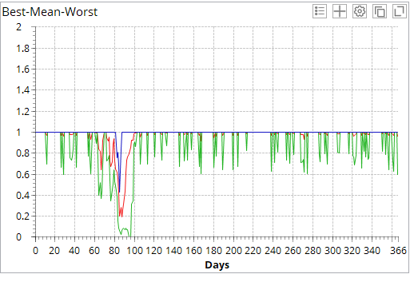 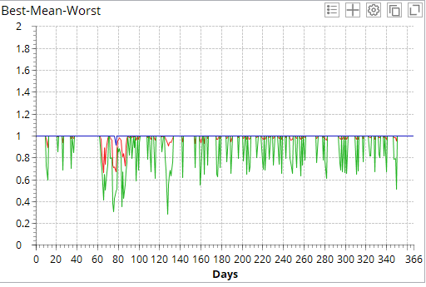

Figure 23. Service level recovery dynamics for supply chains with Chinese (left) and European (right) suppliers

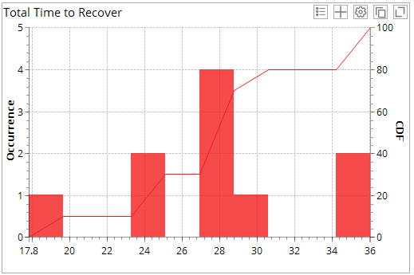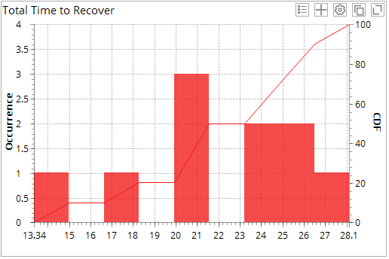

Figure 24. Histograms and CDF for time to recover for supply chains with Chinese (left) and European (right) suppliers. Note the different ranges for the horizontal axis in the two charts

Write up your conclusion on the resilience of the two supply chains based on the Risk analysis experiment.

### Task 5. Assessment of the integral effect of proposed changes with the DuPont model

In this task, you will compare the integral effect of proposed changes using the Strategic Profit Model (DuPont Model). We have provided a template Excel workbook (DuPont – Baseline.xlsx) that you must fill with data from your scenarios. You will find the necessary data in the Economics dashboard (Revenue and cost), Inventory Dashboard (average inventory level), and purchasing price (Sale Batch table).

An example calculation for the baseline scenario is provided in Figure 25.

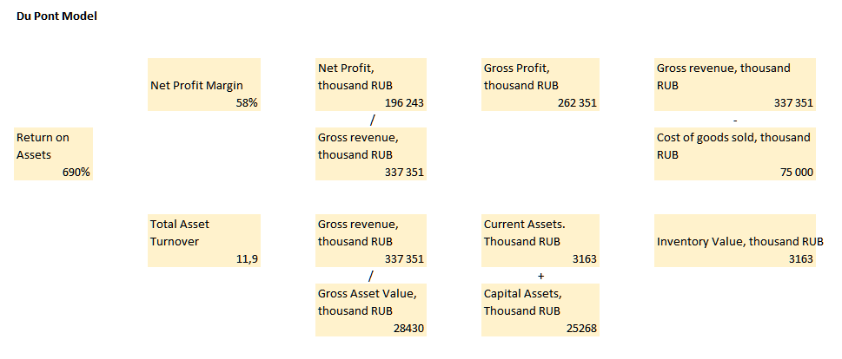

Figure 25. Strategic profit model for the baseline scenario

## Requirements for the report

Write up your analysis results and your recommendations in a report.

The report must include for each task:

* a description of the changes you’ve made to the supply chain data (if there were any), your approach to finding out what parameters to change;
* evidence from the model (tables, screenshots) illustrating the changes in the supply chain performance for a scenario, with your interpretation;
* practical recommendations and conclusion.